**DATA FORMAT:**

* Element – element name
* Id - of the element
* Property - Which property is changed?
* Data – Change of the DOM.

======================================================================

|  |  |  |  |  |
| --- | --- | --- | --- | --- |
| Changes: | Element | ID | Property | DATA -Examples |
| Button Color Change | button | ID of the button to be changed | background-color | Pink/ black |
| Button Bold Font | button | ID of the button to be changed | font-weight | bold |
| Button Italic Font | button | ID of the button to be changed | font-style | italic |
| Button Text Change | button | ID of the button to be changed | Text | previous |
| Button Font Increase | button | ID of the button to be changed | Font-size | Font size |

**JSON Messages - Property Changes Button**

This section is for sending JSON format updates and output on the screen:

=====================================================================

**Button Dynamic Dom Changes:**

**Button background color update:**

URL for sending JSON Data

<http://cs5610-sv27.rhcloud.com/entryincrmentalchanges?element=button&elementid=button1&property=background-color&updatedata=black>

[http://cs5610-sv27.rhcloud.com/entryincrmentalchanges? element=button&elementid=button1&property=background-color&updatedata=pink](http://cs5610-sv27.rhcloud.com/entryincrmentalchanges?elementid=button1&property=background-color&updatedata=pink)

**Before Button Color Change**

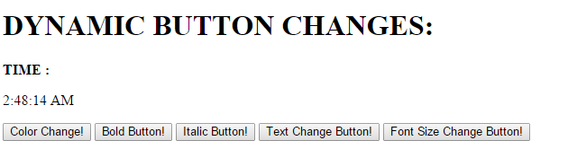

JSON Format:

{

**element**: "button",

**elementid**: "button1",

**property**: "background-color",

**updatedata**: "pink",

}

After Button Color Change

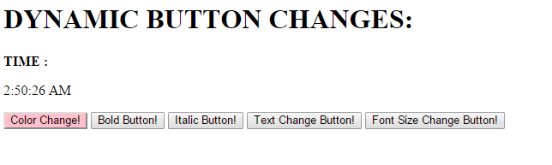

**Button Bold Enable/Disable Update:**

Enable BOLD

JSON Format:

{

**element**: "button",

**elementid**: "button2",

**property**: "font-weight",

**updatedata**: "bold"

}

[http://cs5610-sv27.rhcloud.com/entryincrmentalchanges? element=button&elementid=button2&property=font-weight&updatedata=bold](http://cs5610-sv27.rhcloud.com/entryincrmentalchanges?elementid=button2&property=font-weight&updatedata=bold)

Before:



After:

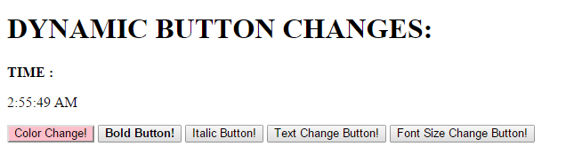

Disable BOLD

JSON Format:

{

**element**: "button",

**elementid**: "button2",

**property**: "font-weight",

**updatedata**: ""

}

[http://cs5610-sv27.rhcloud.com/entryincrmentalchanges? element=button&elementid=button2&property=font-weight&updatedata](http://cs5610-sv27.rhcloud.com/entryincrmentalchanges?elementid=button2&property=font-weight&updatedata)=

Before:



After:

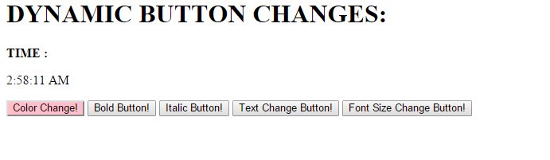

**Button Italic Enable/Disable Update:**

Enable Italic

JSON Format:

{

**element**: "button",

**elementid**: "button3",

**property**: "font-style",

**updatedata**: "italic"

}

[http://cs5610-sv27.rhcloud.com/entryincrmentalchanges? element=button&elementid=button3&property=font-style&updatedata=italic](http://cs5610-sv27.rhcloud.com/entryincrmentalchanges?elementid=button3&property=font-style&updatedata=italic)

Before:

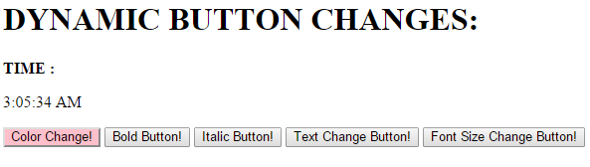

After:

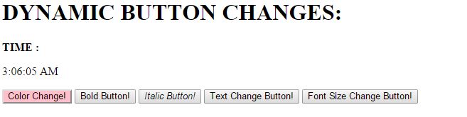

Disable ITALIC

JSON Format:

{

**element**: "button",

**elementid**: "button3",

**property**: "font-style",

**updatedata**: ""

}

[http://cs5610-sv27.rhcloud.com/entryincrmentalchanges? element=button&elementid=button3&property=font-style&updatedata](http://cs5610-sv27.rhcloud.com/entryincrmentalchanges?elementid=button3&property=font-style&updatedata)=

Before:

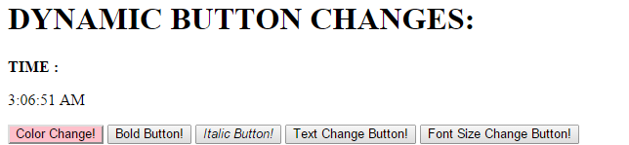

After:

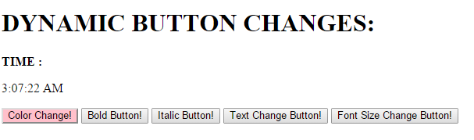

**Button Text Change:**

http://cs5610-sv27.rhcloud.com/entryincrmentalchanges? element=button&elementid=button4&property=text&updatedata=I Have Changed :)

JSON Format:

{

**element**: "button",

**elementid**: "button4",

**property**: "text",

**updatedata**: "I Have Changed :)",

}

Before:



After

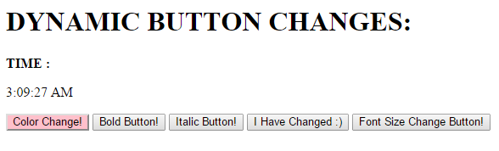

**Button Font size Change:**

[http://cs5610-sv27.rhcloud.com/entryincrmentalchanges? element=button&elementid=button5&property=font-size&updatedata=120%](http://cs5610-sv27.rhcloud.com/entryincrmentalchanges?elementid=button5&property=font-size&updatedata=120%25)

JSON Format:

{

**element**: "button",

**elementid**: "button4",

**property**: "text",

**updatedata**: "I Have Changed :)",

}

Before:

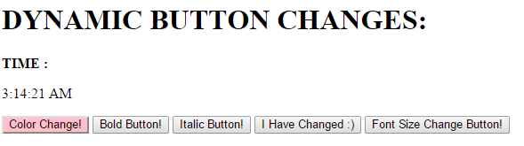

After:

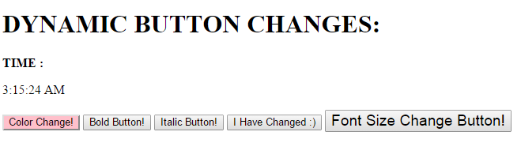

**Reload web Page:**

[http://cs5610-sv27.rhcloud.com/entryincrmentalchanges? element=button&elementid=reload&property=reload&updatedata](http://cs5610-sv27.rhcloud.com/entryincrmentalchanges?elementid=reload&property=reload&updatedata)=

{

**element**: "button",

**elementid**: "reload",

**property**: "reload",

**updatedata**: "",

}

**Before:**

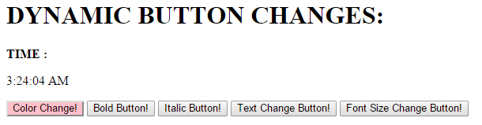

**After:**

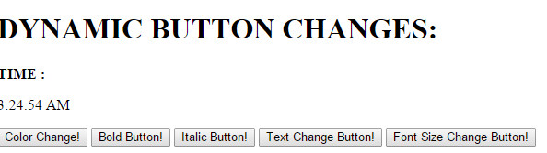

**To see all the incremental Changes:**

http://cs5610-sv27.rhcloud.com/getallincremental

**Web site shows the experiment on Dom Dynamic Update**

http://net4.ccs.neu.edu/home/snehav27/appInventor/DomDynamicUpdate.html

|  |  |  |  |  |
| --- | --- | --- | --- | --- |
| Changes: | Element | ID | Property | DATA -Examples |
| Check Box Color Change | CheckBox | ID of the CheckBox to be changed | background-color | Pink/ black |
| Checkbox checked | CheckBox | ID of the CheckBox to be changed | checked | enabled/disabled |
| Checkbox enabled | CheckBox | ID of the CheckBox to be changed | enabled | enabled/disabled |
| Checkbox Text Change | CheckBox | ID of the CheckBox to be changed | Font-bold Text |  |
| Checkbox Font Increase | CheckBox | ID of the CheckBox to be changed | Font-italic |  |
| Checkbox Font Increase | CheckBox | ID of the CheckBox to be changed | Font-size |  |